# Design, Simulation and Implementation of “*SELF BALANCING ROBOT*” using ARM based Cortex FRZ-KL25Z Microcontroller

*1*Horia Petre, student of MEng. ECE, Concordia University, *2*Diego Mayorga, student of MEng. ECE, Concordia University, *3*Md. Shafayet Sajid, student of MEng. ECE, Concordia University.

## *Abstract – This project is purposely sequel of using ARM based Cortex Microcontroller FRZ-KL25Z to demonstrate the self-balancing technique with Proportional, Integral and Derivative (PID) algorithm which drives two motors coupled with wheels of a structured frame body controlled through an Inertial Measurement Unit (IMU). The Microcontroller was programmed to control the error signal by sensing and keeping it balanced by repositioning the wheel driven structure and move forward autonomously.*

***Index Terms – Microcontroller, Self-Balancing, PID, Motor Drive, Robot.***

## INTRODUCTION

**M**icrocontroller is playing a very vibrant role in electronics field both in home and business applications. It is not only reducing the design complexity but also introduced a new era in Control System. In this project we tried to program an ARM based Cortex Microcontroller (Model: FRZ-KL25Z) which is very cost effective in designing. The project was aimed to control a robot with two wheels that can balance itself autonomously. Designing of circuit, solutions of mathematical equations, writing of logical codes and simulation in ARM complier were the approaches taken in consideration for this project. During the simulation stages, time to time modification of components and codes were also considered for the ease of implementation. The main challenge was stabilizing vertical angle of the robot in PID control logic. Following are the detailed and novel steps that we followed to finalize the project.

## DESIGN COMPONENTS

### i) FRZ-KL25Z Microcontroller, ii) L298N motor drive module, iii) two geared DC motor with wheel, iv) Frame board coupled with motor wheel, v) Bread board, vi) Jumper wires, vii) One no. 9V and four nos. AA rechargeable battery, viii) Wave-100 10 DOF IMU sensor, ix) Bluetooth Module.

## EXPERIMENT & DESIGN

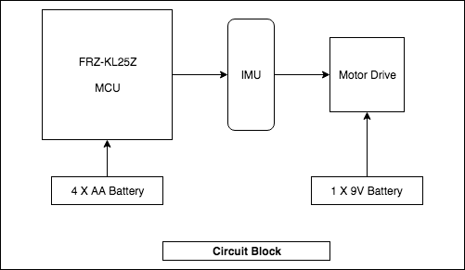

We designed the circuit in such a way that the MCU processed the output of IMU resulting the error which actually sends the instruction to the Motor Drive module and thus balance the two-wheeled frame body, and we call it “self-balancing robot”.

In this experiment our main principal of logic was based on PID control. We set the variables and observed the gains to find the error. Our desired values, acted as an input of PID controller, compared with actual output. Following mathematical equation was considered during simulation.

$$u\left(t\right)=Kp*e\left(t\right)+Kd*\frac{d}{dt}e(t)+Ki*\left(e\left(t\right)\right)$$

1. *MCU: FRZ-KL25Z*

The Microcontroller that we used is very popular one in ARM Cortex Family and it is widely used. It is compact in design with lot of built in integrated facilities such as 32-bit fast I/O access port, 128 KB flash memory, DMA Controller, Voltage regulator, clocks, 12 bit DAC, PWM module, Accelerometer etc. We powered the board with 4 nos. AA battery and we designed a common ground in the bread board so that no value is floated in the circuit.

1. *IMU: 10 DOF (Degrees of Freedom)*

In the circuit, we utilized the IMU as a main sensor. It acted as an accelerometer and gyroscopes. It measures and reports orientation, velocity and gravitational forces through accelerometer and gyroscopes. In our code we have set variable parameters and when the angular value is changed and compared then it controlled the speed of the motor maintaining the codes of conduct.

1. *Motor Drive Module (L298N)*

### We have used this dual (H-bridge) bidirectional motor driver in the circuit as it can easily and independently control two motors of up to 2A each in both directions. It has also heat sync and can handle up to 35V. We powered this module through 9V battery. We connected the output pin to two motors and wrote a short code of PWM controller to control directly from the MCU and actual values from the IMU.

### *Bluetooth Module*

### We have also used a Bluetooth module to control it remotely. We have developed a mobile application so that we can control the direction and speed from our mobile devices.

1. *Control Method*

Our main function executes based on the popular control theory PID technique where Kp, Ki and Kd are the gain which are compared to previously set values as reference.

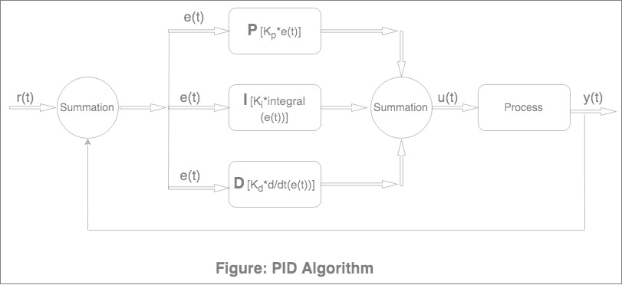

This controller detects errors on the basis of reference value and give its output. The IMU sense the actual angular position and feed the data to PID algorithm to determine the error as a comparison. Thus said robot balance autonomously.

1. *Power Management*

We have used two rechargeable DC battery so that it can act as a power source when moving autonomously. We have used four nos. Li-Po 1200 mAh (1.2 Amps for an hour) rechargeable 14500/AA battery in series which can supply the desired power to the FRDM-KL25Z board. Each battery is 1.5V so we were getting 6V nominal voltage at its full charged state. We used Vin PIN of the I/O headers (J9 pin 16) which can take voltage 4.3 - 9 V (as per data sheet) grounding in PIN 14. Typical discharge characteristics is shown below:

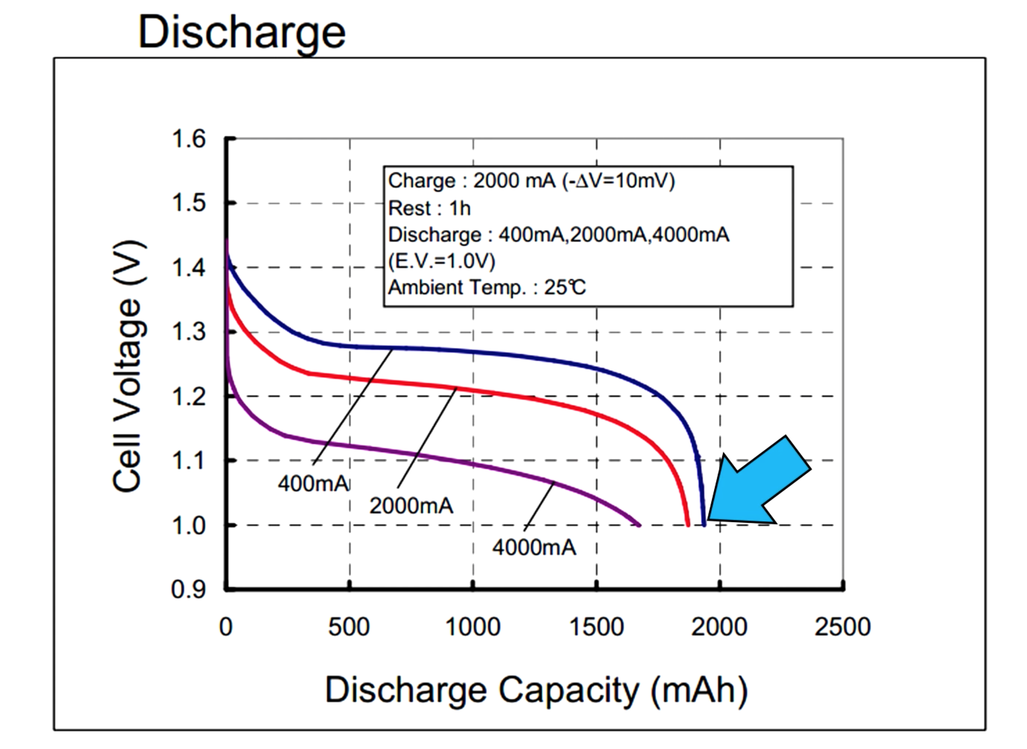

We also used one 9V battery separately for powering Motor Controller which can take 9 – 35V. We created a common ground using a bread board from MCU and connected Motor Controller to its ground pin.

We powered the IMU from the internal output power of the FRDM board from PIN 3.3 V.

## CODES & RESULTS

The Microcontroller has its own compiler and we coded with the language C for ARM based MCU. Following topology of coding were used for the complete operation:

1. MCU Control
2. IMU Control
3. PID Control
4. Motor Control
5. *Codes:*
6. *Results*